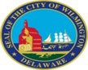
Finance Committee Budget Hearing Office of Economic Development April 21, 2025

- With the evolving changes regarding Federal Grant Funding, while understanding possible legal challenges, share if this budget addresses any contingency funds or planning for assisting small minority business programs and non-profits that could bare the most financial impact with regards to diversity, inclusion, etc. that perhaps could be on the chopping block for federal funding.
- OED did not budget additional funds to support Small Minority Businesses outside of the funds designated in the Strategic Fund Minority Business Set-Aside and Operating Funds, specifically the SMBEO FY26 budget of $26,000 and Consulting funds. As new needs arise, we look to creatively work with businesses on a case-by-case basis to help overcome obstacles and challenges in real time.
a. Share the number of small minority businesses in the City of Wilmington.
- 170 active Minority Owned Small Businesses in the City of Wilmington according to business data research firm Dun & Bradstreet as of April 2025.
b. Share the number of businesses in the City of Wilmington.
- 2895 City of Wilmington business licenses were issued in 2024.
c. Share the number of non-profits in the City of Wilmington.
- 922 active 501(c)(3) organizations in the City of Wilmington according to nonprofit data research firm GuideStar as of April 2025.

- Considering that one of Council’s budget priorities is Economic Development, please share how this budget is in alignment with that priority by specifying the following:
a. Any funds specifically allocated for the Small Minority Business Program set aside from the Economic Development Strategic Funds.
- $350,000 in the Minority Business Strategic Fund Set-Aside which was approved in the FY25 budget. Strategic Funds that are not set aside for minority businesses can be further utilized if the set-aside funds are spent.
b. Any fiscal budgetary funding set aside for fully implementing many of the recommendations from the Disparity Report that could perhaps increase business growth in Wilmington. i. Since this report has been issued, share if there has been any growth with Disadvantage Business Enterprise (DBE’s).
- $22,600 SMBEO budget will continue to be used to operate the program. We use these funds to pay for expenses related to SMBEO events and operating expenses. We also pay consultants out of this budget. Some examples of consultants funded on behalf of small businesses are 1) needs assessments performed by Savoury Consulting, 2) education classes like the social media for Small Business class performed by Aliya Hammond Consulting, and 3) administrative support to small businesses who need help applying for programs such as the DDD or loan applications.
i. Since this report has been issued (Feb 2023), share if there has been any growth with Disadvantaged Business Enterprise (DBE’s).
- 46 new DBE's certified calendar year 2024, 15% Increase year over year; 8 renewals completed calendar year 2024.
- OED is working to implement a DBE dashboard to help provide quantitative data on DBE participation. At this time, the majority of DBE participation is as Subcontractors, and the City does not have sight into how our contractors sub out work. We review bids for projects over $60K and have seen an increase in the submissions that have higher previous DBE subcontract bids being included in bid packs. Anecdotally, we also believe the % share of dollars going to DBE subs on bids submitted has increased from pre disparity study times. Our office regularly fields inquiries from vendors to help match their needs with Ready, Willing, and Able subcontractors for bids.
ii. Provide list of certified DBE’s and the corelating industry.
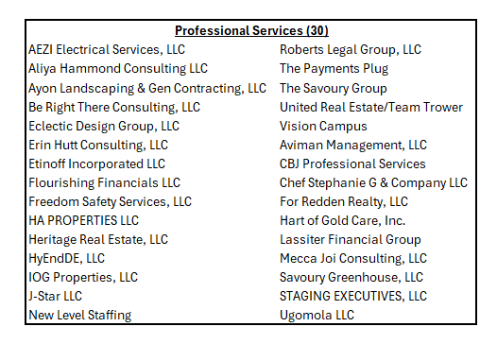
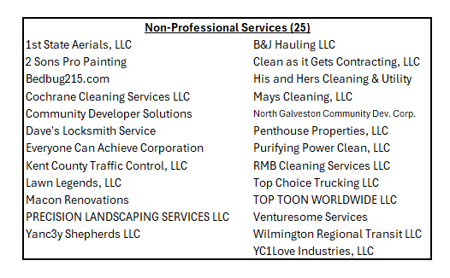
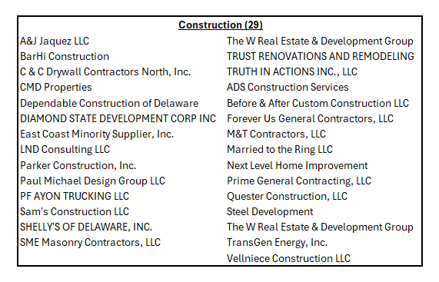
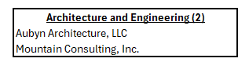
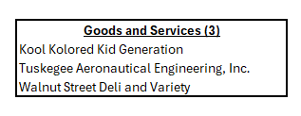
iii. Specify any funding set aside for tracking data.
- $40K within IT budget for FY ‘26 B2GNow subscription including the contract compliance module (implementation underway)
- ThirdLine to develop Procurement reporting including DBE dashboard
- DBE Administrator Position Hired FY '24: Salary moved from Finance into OED going forward

- Since Wilmington UDAG Corp (WUC) entered into a Multi-Party Loan and Participation Agreement (MPLPA) with Grow America Fund, Inc. (GAF) and Discover Bank to establish a revolving loan fund (the Grow Wilmington Fund) intended to make loans to small businesses (Program Loans) in the City of Wilmington under the Small Business Act, please share the number of small businesses in Wilmington that has benefited from this collaboration within the last 2 years and the amounts.
- Wilmington UDAG Corp entered into an agreement with Grow America Fund and Discover Bank in October 2014 to establish the Grow Wilmington Fund to make loans to small businesses in the City of Wilmington. Since the Grow Wilmington Fund launched, there have been $4,287,000 in total loans made across 8 Wilmington businesses and 78 total jobs retained or created. $481,773 in funds are available to invest
- Other loan funds utilized over the last 2 years include ARPA payments to 8 small businesses totaling $95K, Grow New Castle County Fund with $700,000 in loans approved for Wilmington businesses since the fund was announced on April 2023, and $150,000 in WEDCO loans to 5 small businesses within the last 2 years.

4. Notwithstanding that OED’s FY2026 budget total ~$1.17M; share the percentage of this budget that are direct cost for the small minority business program.
a. Please specify all budgetary cost for the program.
- SMBEO FY26 Budget: $22,600. These funds are dedicated to support procurement events expected in FY26 including True Access Capital Fair, SBDC Procurement Fair, NCCo Diverse Vendor Fair, SBA Procurement Webinars, APEX Accelerator, Turner Construction Class (Q3 2025), and DBE Day Events with City Departments.
- The Strategic Funds and Operating Budget can be utilized to support small minority businesses even though the funds are not specifically set aside for small minority businesses. Examples include 1) utilizing the Strategic Fund to support property investment such as Signage, Façade improvement, Architecture and Engineering Feasibility Studies; and 2) using Consulting funds from the Operating Budget to expense consultants that can prepare business needs assessments, social media marketing strategy, or application support for partner incentives and funding opportunities.

5. Discuss the incentives the City of Wilmington offers to major and small businesses seeking to relocate to the City of Wilmington, as well as to attract and retains businesses to keep Wilmington competitive and on par.
- Strategic Funds are the primary funding source OED uses for business attraction, expansion, and retention efforts. Offers to major businesses, particularly those outside of the State, often require collaboration with the Delaware Prosperity Partnership. Offers to small businesses partner with local community development financial institutions such as WEDCO, True Access Capital, and Grow America Fund for underwriting support and tri-party loan agreements.
a. Specify if any joint collaborative efforts with the State of Delaware, and if so, share if any funding allocations, etc.
- Collaborative efforts with the State of Delaware include the Delaware Prosperity Partnership, Division of Small Business, DelDOT, and Delaware State Housing Authority. Strategic Fund offers to out-of-state businesses often partner with the Delaware Prosperity Partnership for job incentive agreements approved by the Council on Development Finance. The Division of Small Business offers funding for small businesses in Wilmington via the competitive EDGE grant and products such as the Small Business Credit Initiative. DelDOT is currently administering a Transportation Infrastructure Investment Fund (TIIF) grant of $4.67M to be used for infrastructure improvements for the 7th Street Peninsula; The Department of Public Works has funded initial costs of the project and expects reimbursement by the TIIF fund in accordance with the agreement. Delaware State Housing Authority has dedicated $3,906,371 in reservation awards in the latest round of Downtown Development District funding (Round 16).
b. Specify if any support for Cultural Restoration Project.
- The Cultural Restoration Project became a 501(c)3 organization in 2016. The City of Wilmington committed $150,000 to the Cultural Restoration Project using ARPA funds. OED cannot offer additional funds for non-profit programming.
c. Specify number of new businesses within the last 2 years.
- According to business permitting data on Tolemi, the number of business licenses issued by the City increased from 2737 in 2022, to 2853 in 2023, and 2895 in 2024. In summary, 158 additional business licenses were issued in the last 2 years, or a 5.77% increase.
d. Any plans to make OED’s website more user friendly.
- OED plans to link the office’s website (choosewilmingtonde.org) under the City’s website to streamline information in a user-friendly format. Since 2021, OED has worked with economic development website consultant Golden Shovel to develop and host the office website. According to Golden Shovel’s most recent website audit, OED’s website received a letter grade of "A" in the categories of Usability, On-Page SEO, and Performance.
e. Share potential impact to Wilmington if SB# 33 passes: i. This Act builds on the success of the Downtown Development Districts Act, Chapter 19 of Title 22 of the Delaware Code, by permitting a municipality with a population of 30,000 or more in the 2020 federal census, which includes Wilmington, Dover, and Newark, to designate an area in the municipality as a "Downtown Development Corridor". This Act also makes technical corrections to conform existing law to the standards of the Delaware Legislative Drafting Manual.
- According to the 2024 Delaware State Housing Authority Annual DDD report, since 2015 the State has invested $26.7M in completed projects leveraging $466M in Private Investment across 50 Large Projects and 54 Small Projects in Wilmington. The current district boundary is set to 275 Acres. The potential impact of an additional downtown development corridor is contingent on the corridor location, increased acreage allowed, and State funding increases for the DDD program. SB#33 is currently “awaiting consideration in the Senate Elections & Government Affairs Committee”.

6. Discuss the planned budgetary use for $1.8M fund balance in the Strategic Fund as of the latest Annual Comprehensive Financial Report, considering the fund balance has been a similar amount for the last 2 fiscal years.
a. Specify projects in the pipeline and anticipated revenues.
- Of the three pipeline projects that are currently in progress, OED estimates that the City will receive roughly $40,685 in combined wage tax and permit fees. These projects cumulatively account for about $1.9 million in private investment in the City.
b. Specify the amount of cash infusions since inception.
- Total Funding since 2002 was $18,710,000 across 10 rounds of funding. The total returns to date in terms of wage taxes paid by businesses that entered a Strategic Fund agreement are $158,804,171.
c. Specify current amount committed.
- In FY2025, OED spent $824,513 in expenditures, $279,750 in encumbrances, and received a repayment of $300,000 to bring the total fund balance as of April 2025 to $1,363,703.
d. Specify funding allocated for small business, minority business.
- $515,655 in total expenditures for small and/or minority business in FY '25.
e. Specify amount of funds set aside for the Minority Business Development Program, and the available fund balance.
- $409,596 in total expenditures for small minority business in FY '25. The $350,000 Minority Business Set-Aside has been spent down with an additional $37,853 Strategic Fund contribution.
i. Provide an update on amounts provided for program since inception.
- $1,150,000 in total Minority business set-aside since the program’s inception and $1,187,853 in total expenditures.
7. Discuss the amount of revenues generated and collected directly as a result of the Office of Economic Development efforts for FY2023 through FY2025 year to date.
- Wage Taxes Collected from Strategic Fund Businesses include $10,959,257.63 in calendar year 2024, $10,454,103.40 in calendar year 2023, and $10,117,042.23 in calendar year 2022. The total returns to date in terms of wage taxes paid by businesses that entered a Strategic Fund agreement to date are $158,804,171.
8. Discuss the planned use of $110K budgeted for Consultants. a. Specify any DBE’s.
- OED plans to use $95,000 in Consulting Support for Development & Infrastructure Projects and $15,000 for consultant services for SMBEO programing. These funds are available for economic development planning efforts, small business consulting services, and software subscriptions relevant for economic development.

9. Discuss the planned use for ~$16K budgeted for Advertising/Marketing. a. Share the number of businesses the City marketed the last 2 years.
- $13,700 for City-oriented advertising, website, & promotional content in local & regional publications and $2,000 to promote City of Wilmington small & minority business initiatives classes and related outreach (in SMBEO).
a. Share the number of businesses the City marketed the last 2 years.
- OED does not advertise individual business instead opting for promoting events and working with our partners to support multiple Wilmington businesses. Events supported over the last 2 fiscal years include Restaurant Week, Black Restaurant Week, Lady Bug Festival, and Brandywine Arts Festival. OED partners that have advertised Wilmington businesses over the last 2 fiscal years include Greater Wilmington Convention and Visitors Bureau, Downtown Visions, King Creative, and DETV.

10. Provide FY26 proposed organizational chart with the total number of employees (i.e. permanent, temporary, contract, vacancies).
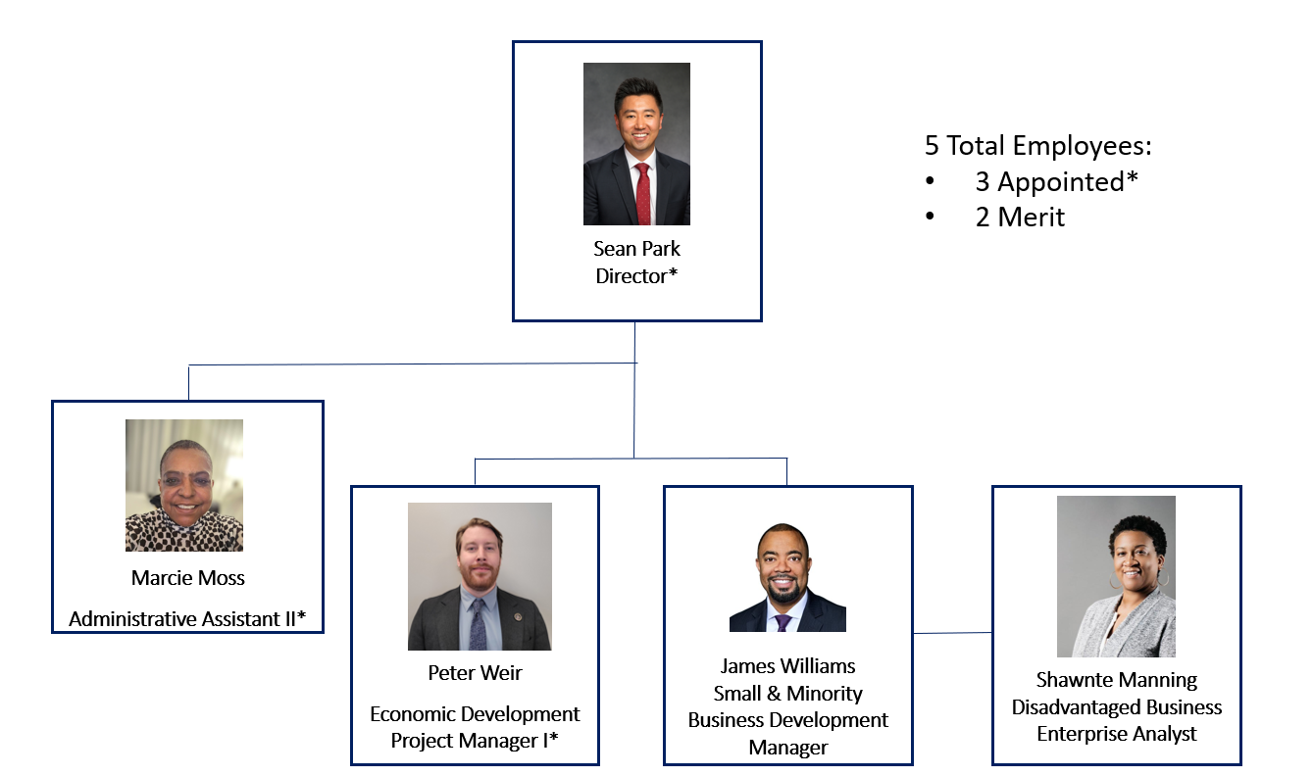
Capital
11. Provide planned use of funding allocated for the following capital projects:
a. $500K Infrastructure and Site Improvement Closing Fund
- The purpose of the Infrastructure and Site Improvement Closing Fund is to have funds available for public infrastructure and site improvements that impact economic development. Eligible uses include infrastructure expenses such as construction of new roads, utilities, site preparation work, and environmental remediation.
b. $500K Site Acquisition
- The purpose of the Site Acquisition Fund is to have funds available for land acquisition with a focus on preventing the expansion of undesirable commercial uses in underutilized and blighted areas. Recently, these funds have been utilized to acquire parcels relevant to Phase II of the Wetlands Park.

